Liturature Survay and document evaluvation

Date:07/07/2023
1)https://circuitdigest.com/microcontroller-projects/interfacing-rain-sensor-with-arduino

The working principle of the Rain Detection Sensor is pretty simple, as you can see in the image below. The PCB is made out of multiple exposed log conductive plates arranged in a grid format. When rain falls on top of the sensor the resistivity of the conductive plates changes, and by measuring the changes in the resistance, we can determine the intensity of the rainfall. The more intense the rainfall the lower the resistance.

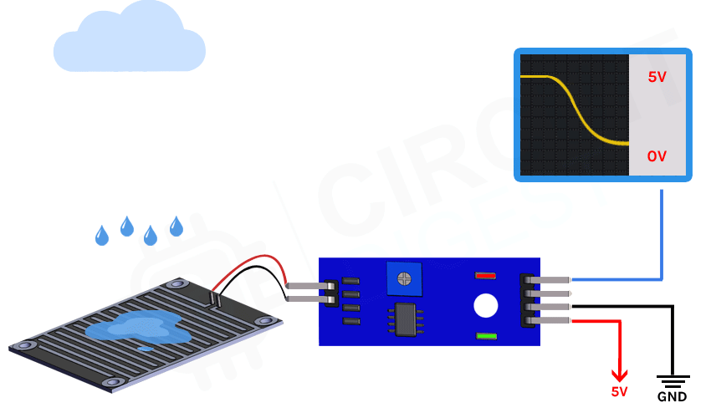
The above Animation of the Rain Detection Sensor shows how the analog output of the sensor changes based on the water droplets falling on top of it. As you can see in the animation above the voltage slowly drops from VCC to 0V when water droplets start falling from the top, you can also see that the trigger LED on the board turns on when a certain threshold is reached which can be set by the potentiometer. For the sake of simplicity, we did not make any visual representation of how the digital part of the circuit works, but it's pretty simple when a certain threshold is reached (that we can set by a potentiometer) the output of the rain detection sensor module goes low and that lights up the onboard trigger LED.

